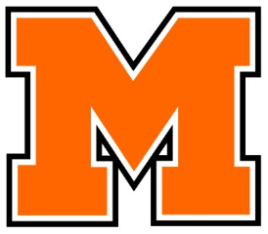
Yearbook Order Form
The 2017 Arrow

Please fill out 1 Form per Student

Today's Date:___________________________

Student Name: _________________________________________________ Contact #: _____________________________________

Grade: (circle one) Senior Junior Sophomore Freshman Non-Student

>> ONLY orders PAID IN FULL by WINTER BREAK will include a NAME STAMP on the cover.
CLEARLY PRINT the name EXACTLY as you would like it to appear on the front of the book.
Yearbook staff reserves the right to deny nicknames
– 1 letter/space per box – 30 characters maximum –
The yearbook staff will NOT be responsible for misspelled name stamps if writing is illegible.

Pricing (must be paid in full at time of order):

$65 Paid before December 16, 2016
$70 Paid after January 1, 2017

ITEM | PRICE  By Dec 16 | PRICE  After Jan 1 | # COPIES | TOTAL
2016 Molalla Arrow Yearbook | $65.00 | $70.00
Donate a Yearbook to a Senior | $65.00 | $70.00
Total Amount Due

Cash Accepted. Check or Money Order payable to: Molalla High School Yearbook
Mailing Address: Molalla High School, Yearbook Order, 357 Frances Street, Molalla, OR 97038

QUESTIONS? yearbook@molallariv.k12.or.us / 503.829.2355 x7376

PLEASE RETURN FORM & PAYMENT TO MRS. HATSWELL, MHS ACCOUNTING OFFICE

OFFICE USE ONLY: ORDER REC’D______/______/______ AMT PAID IN FULL $_______________

